CBG Admin Portal

Screen MockUPs

Ravi Panchal

2017

# Login Page

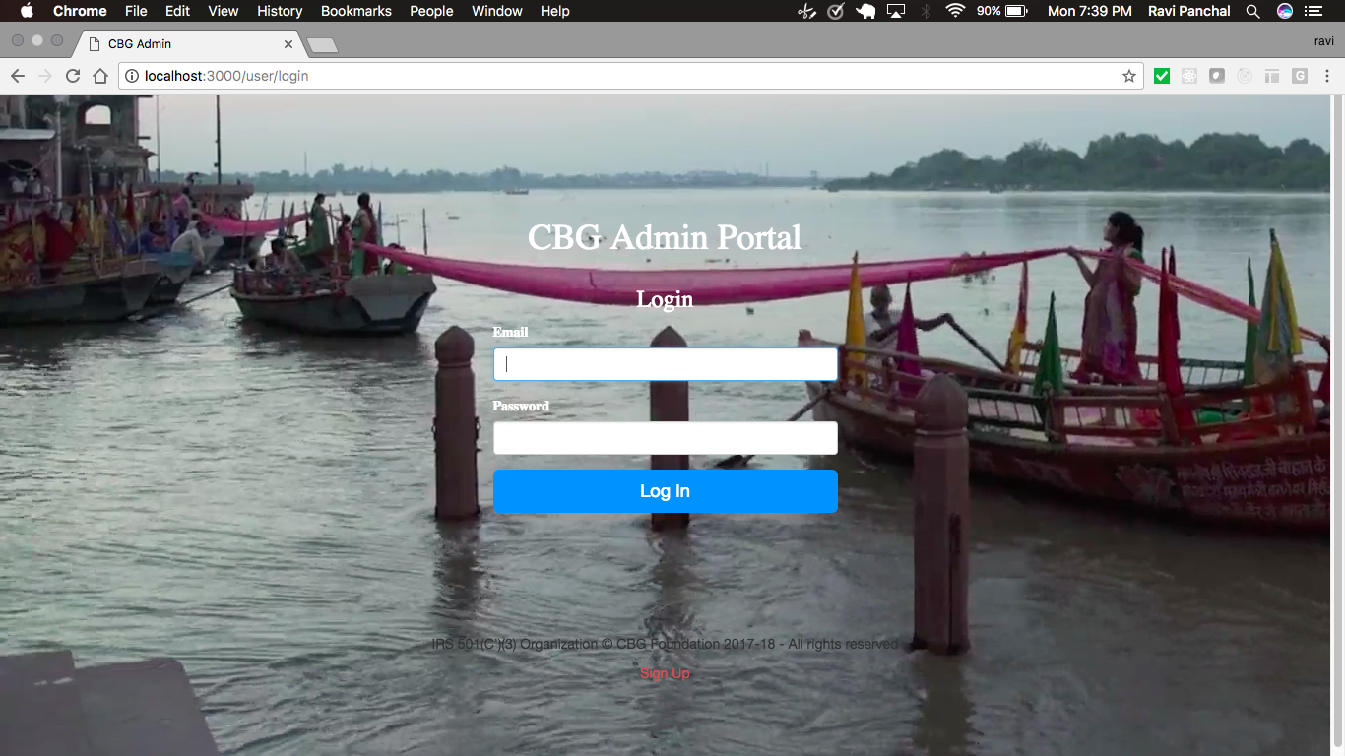

* This Page shall allow registered user to Login to CBG Admin Portal.
* User shall be able to use registered Email Address & Password to Login to Portal.
* The Password will be Hashed(crypted) in Database.
* The UI uses video background which is not seen in the screenshot

# User Sign Up Page:

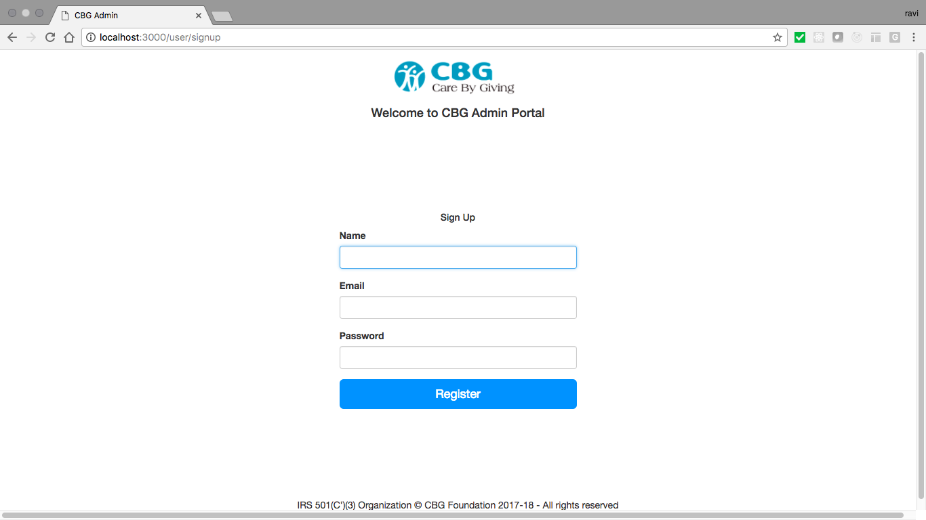

* This Page shall user to Sign up for access to CBG Admin Portal.
* User will need to Provide their Name, Email Address & Password for Signup.
* This Page will only be used to create user to the CBG Admin Portal and only Super Users will have access to this page.

CBG Admin Dashboard:

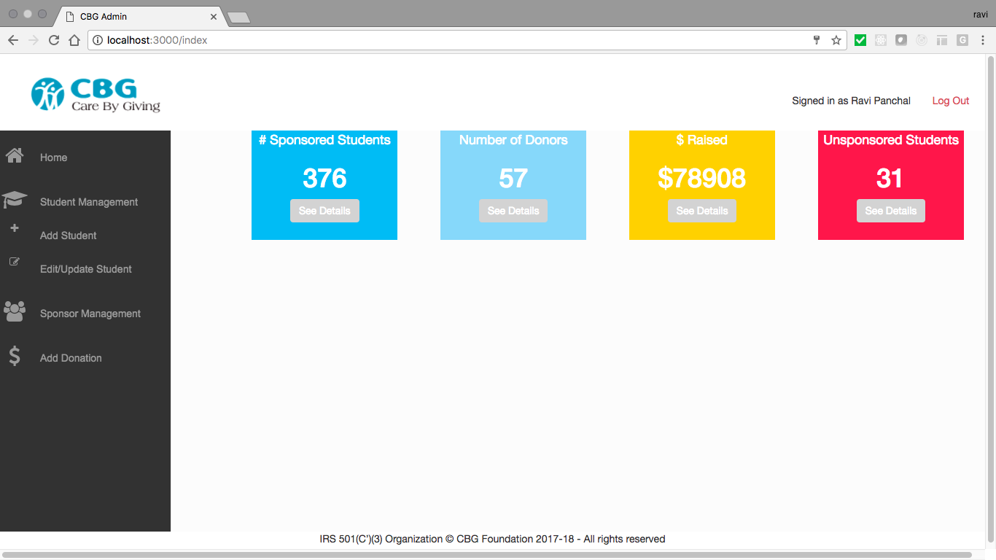

* This Page will Provide Dashboard details such as Number of Students Sponsored in current Year, Number of Donors, Money Raised and Unsponsored Students.
* This Page shall allow User Add ,Update/Edit Student data.
* This Page shall allow user to Add/Update Sponsor Data
* This Page shall allow user to Add Adhoc Donations.

# Features / Functionality in Progress:

UI Design and Database development for Student Management.

🡪 Target Date: 11/25/2017

UI Design and Database development for Sponsor Management.

🡪 Target Date: 11/25/2017

Data Entry / Data Input

🡪 Target Date: 12/01/2017